學生成績預測模型訓練報告

--這是由學生成績預測系統自動生成的報告

--作者: 林威成、陳宥呈、廖泓閔

# 訓練模型 - NN模型

選擇要訓練的模型：NN模型

要訓練的參數：

|  |  |
| --- | --- |
| index | info |
| 0 | school |
| 1 | sex |
| 2 | age |
| 3 | address |
| 4 | Medu |
| 5 | Fedu |
| 6 | traveltime |
| 7 | studytime |
| 8 | failures |
| 9 | higher |
| 10 | internet |
| 11 | freetime |
| 12 | Dalc |
| 13 | Walc |
| 14 | absences |
| 15 | G1 |
| 16 | G2 |

要訓練的結果：NN模型

# 一、資料前處理

1. 讀取原本的資料 : (649, 33) [前15項]

|  |  |  |  |  |  |  |  |  |  |  |  |  |  |  |  |  |  |  |  |  |  |  |  |  |  |  |  |  |  |  |  |  |  |
| --- | --- | --- | --- | --- | --- | --- | --- | --- | --- | --- | --- | --- | --- | --- | --- | --- | --- | --- | --- | --- | --- | --- | --- | --- | --- | --- | --- | --- | --- | --- | --- | --- | --- |
| index | school | sex | age | address | famsize | Pstatus | Medu | Fedu | Mjob | Fjob | reason | guardian | traveltime | studytime | failures | schoolsup | famsup | paid | activities | nursery | higher | internet | romantic | famrel | freetime | goout | Dalc | Walc | health | absences | G1 | G2 | G3 |
| 0 | GP | F | 18 | U | GT3 | A | 4 | 4 | at_home | teacher | course | mother | 2 | 2 | 0 | 1 | 0 | 0 | 0 | 1 | 1 | 0 | 0 | 4 | 3 | 4 | 1 | 1 | 3 | 4 | 0 | 11 | 11 |
| 1 | GP | F | 17 | U | GT3 | T | 1 | 1 | at_home | other | course | father | 1 | 2 | 0 | 0 | 1 | 0 | 0 | 0 | 1 | 1 | 0 | 5 | 3 | 3 | 1 | 1 | 3 | 2 | 9 | 11 | 11 |
| 2 | GP | F | 15 | U | LE3 | T | 1 | 1 | at_home | other | other | mother | 1 | 2 | 0 | 1 | 0 | 0 | 0 | 1 | 1 | 1 | 0 | 4 | 3 | 2 | 2 | 3 | 3 | 6 | 12 | 13 | 12 |
| 3 | GP | F | 15 | U | GT3 | T | 4 | 2 | health | services | home | mother | 1 | 3 | 0 | 0 | 1 | 0 | 1 | 1 | 1 | 1 | 1 | 3 | 2 | 2 | 1 | 1 | 5 | 0 | 14 | 14 | 14 |
| 4 | GP | F | 16 | U | GT3 | T | 3 | 3 | other | other | home | father | 1 | 2 | 0 | 0 | 1 | 0 | 0 | 1 | 1 | 0 | 0 | 4 | 3 | 2 | 1 | 2 | 5 | 0 | 11 | 13 | 13 |
| 5 | GP | M | 16 | U | LE3 | T | 4 | 3 | services | other | reputation | mother | 1 | 2 | 0 | 0 | 1 | 0 | 1 | 1 | 1 | 1 | 0 | 5 | 4 | 2 | 1 | 2 | 5 | 6 | 12 | 12 | 13 |
| 6 | GP | M | 16 | U | LE3 | T | 2 | 2 | other | other | home | mother | 1 | 2 | 0 | 0 | 0 | 0 | 0 | 1 | 1 | 1 | 0 | 4 | 4 | 4 | 1 | 1 | 3 | 0 | 13 | 12 | 13 |
| 7 | GP | F | 17 | U | GT3 | A | 4 | 4 | other | teacher | home | mother | 2 | 2 | 0 | 1 | 1 | 0 | 0 | 1 | 1 | 0 | 0 | 4 | 1 | 4 | 1 | 1 | 1 | 2 | 10 | 13 | 13 |
| 8 | GP | M | 15 | U | LE3 | A | 3 | 2 | services | other | home | mother | 1 | 2 | 0 | 0 | 1 | 0 | 0 | 1 | 1 | 1 | 0 | 4 | 2 | 2 | 1 | 1 | 1 | 0 | 15 | 16 | 17 |
| 9 | GP | M | 15 | U | GT3 | T | 3 | 4 | other | other | home | mother | 1 | 2 | 0 | 0 | 1 | 0 | 1 | 1 | 1 | 1 | 0 | 5 | 5 | 1 | 1 | 1 | 5 | 0 | 12 | 12 | 13 |
| 10 | GP | F | 15 | U | GT3 | T | 4 | 4 | teacher | health | reputation | mother | 1 | 2 | 0 | 0 | 1 | 0 | 0 | 1 | 1 | 1 | 0 | 3 | 3 | 3 | 1 | 2 | 2 | 2 | 14 | 14 | 14 |
| 11 | GP | F | 15 | U | GT3 | T | 2 | 1 | services | other | reputation | father | 3 | 3 | 0 | 0 | 1 | 0 | 1 | 1 | 1 | 1 | 0 | 5 | 2 | 2 | 1 | 1 | 4 | 0 | 10 | 12 | 13 |
| 12 | GP | M | 15 | U | LE3 | T | 4 | 4 | health | services | course | father | 1 | 1 | 0 | 0 | 1 | 0 | 1 | 1 | 1 | 1 | 0 | 4 | 3 | 3 | 1 | 3 | 5 | 0 | 12 | 13 | 12 |
| 13 | GP | M | 15 | U | GT3 | T | 4 | 3 | teacher | other | course | mother | 2 | 2 | 0 | 0 | 1 | 0 | 0 | 1 | 1 | 1 | 0 | 5 | 4 | 3 | 1 | 2 | 3 | 0 | 12 | 12 | 13 |
| 14 | GP | M | 15 | U | GT3 | A | 2 | 2 | other | other | home | other | 1 | 3 | 0 | 0 | 1 | 0 | 0 | 1 | 1 | 1 | 1 | 4 | 5 | 2 | 1 | 1 | 3 | 0 | 14 | 14 | 15 |

2. 將資料只留下要訓練的欄位 : (649, 18) [前15項]

|  |  |  |  |  |  |  |  |  |  |  |  |  |  |  |  |  |  |  |
| --- | --- | --- | --- | --- | --- | --- | --- | --- | --- | --- | --- | --- | --- | --- | --- | --- | --- | --- |
| index | school | sex | age | address | Medu | Fedu | traveltime | studytime | failures | higher | internet | freetime | Dalc | Walc | absences | G1 | G2 | G3 |
| 0 | GP | F | 18 | U | 4 | 4 | 2 | 2 | 0 | 1 | 0 | 3 | 1 | 1 | 4 | 0 | 11 | 11 |
| 1 | GP | F | 17 | U | 1 | 1 | 1 | 2 | 0 | 1 | 1 | 3 | 1 | 1 | 2 | 9 | 11 | 11 |
| 2 | GP | F | 15 | U | 1 | 1 | 1 | 2 | 0 | 1 | 1 | 3 | 2 | 3 | 6 | 12 | 13 | 12 |
| 3 | GP | F | 15 | U | 4 | 2 | 1 | 3 | 0 | 1 | 1 | 2 | 1 | 1 | 0 | 14 | 14 | 14 |
| 4 | GP | F | 16 | U | 3 | 3 | 1 | 2 | 0 | 1 | 0 | 3 | 1 | 2 | 0 | 11 | 13 | 13 |
| 5 | GP | M | 16 | U | 4 | 3 | 1 | 2 | 0 | 1 | 1 | 4 | 1 | 2 | 6 | 12 | 12 | 13 |
| 6 | GP | M | 16 | U | 2 | 2 | 1 | 2 | 0 | 1 | 1 | 4 | 1 | 1 | 0 | 13 | 12 | 13 |
| 7 | GP | F | 17 | U | 4 | 4 | 2 | 2 | 0 | 1 | 0 | 1 | 1 | 1 | 2 | 10 | 13 | 13 |
| 8 | GP | M | 15 | U | 3 | 2 | 1 | 2 | 0 | 1 | 1 | 2 | 1 | 1 | 0 | 15 | 16 | 17 |
| 9 | GP | M | 15 | U | 3 | 4 | 1 | 2 | 0 | 1 | 1 | 5 | 1 | 1 | 0 | 12 | 12 | 13 |
| 10 | GP | F | 15 | U | 4 | 4 | 1 | 2 | 0 | 1 | 1 | 3 | 1 | 2 | 2 | 14 | 14 | 14 |
| 11 | GP | F | 15 | U | 2 | 1 | 3 | 3 | 0 | 1 | 1 | 2 | 1 | 1 | 0 | 10 | 12 | 13 |
| 12 | GP | M | 15 | U | 4 | 4 | 1 | 1 | 0 | 1 | 1 | 3 | 1 | 3 | 0 | 12 | 13 | 12 |
| 13 | GP | M | 15 | U | 4 | 3 | 2 | 2 | 0 | 1 | 1 | 4 | 1 | 2 | 0 | 12 | 12 | 13 |
| 14 | GP | M | 15 | U | 2 | 2 | 1 | 3 | 0 | 1 | 1 | 5 | 1 | 1 | 0 | 14 | 14 | 15 |

3. 轉換訓練資料的欄位 : (649, 18) [前15項]

|  |  |  |  |  |  |  |  |  |  |  |  |  |  |  |  |  |  |  |
| --- | --- | --- | --- | --- | --- | --- | --- | --- | --- | --- | --- | --- | --- | --- | --- | --- | --- | --- |
| index | school | sex | age | address | Medu | Fedu | traveltime | studytime | failures | higher | internet | freetime | Dalc | Walc | absences | G1 | G2 | G3 |
| 0 | 1 | 1 | 18 | 1 | 4 | 4 | 2 | 2 | 0 | 1 | 0 | 3 | 1 | 1 | 4 | 0 | 11 | 11 |
| 1 | 1 | 1 | 17 | 1 | 1 | 1 | 1 | 2 | 0 | 1 | 1 | 3 | 1 | 1 | 2 | 9 | 11 | 11 |
| 2 | 1 | 1 | 15 | 1 | 1 | 1 | 1 | 2 | 0 | 1 | 1 | 3 | 2 | 3 | 6 | 12 | 13 | 12 |
| 3 | 1 | 1 | 15 | 1 | 4 | 2 | 1 | 3 | 0 | 1 | 1 | 2 | 1 | 1 | 0 | 14 | 14 | 14 |
| 4 | 1 | 1 | 16 | 1 | 3 | 3 | 1 | 2 | 0 | 1 | 0 | 3 | 1 | 2 | 0 | 11 | 13 | 13 |
| 5 | 1 | 2 | 16 | 1 | 4 | 3 | 1 | 2 | 0 | 1 | 1 | 4 | 1 | 2 | 6 | 12 | 12 | 13 |
| 6 | 1 | 2 | 16 | 1 | 2 | 2 | 1 | 2 | 0 | 1 | 1 | 4 | 1 | 1 | 0 | 13 | 12 | 13 |
| 7 | 1 | 1 | 17 | 1 | 4 | 4 | 2 | 2 | 0 | 1 | 0 | 1 | 1 | 1 | 2 | 10 | 13 | 13 |
| 8 | 1 | 2 | 15 | 1 | 3 | 2 | 1 | 2 | 0 | 1 | 1 | 2 | 1 | 1 | 0 | 15 | 16 | 17 |
| 9 | 1 | 2 | 15 | 1 | 3 | 4 | 1 | 2 | 0 | 1 | 1 | 5 | 1 | 1 | 0 | 12 | 12 | 13 |
| 10 | 1 | 1 | 15 | 1 | 4 | 4 | 1 | 2 | 0 | 1 | 1 | 3 | 1 | 2 | 2 | 14 | 14 | 14 |
| 11 | 1 | 1 | 15 | 1 | 2 | 1 | 3 | 3 | 0 | 1 | 1 | 2 | 1 | 1 | 0 | 10 | 12 | 13 |
| 12 | 1 | 2 | 15 | 1 | 4 | 4 | 1 | 1 | 0 | 1 | 1 | 3 | 1 | 3 | 0 | 12 | 13 | 12 |
| 13 | 1 | 2 | 15 | 1 | 4 | 3 | 2 | 2 | 0 | 1 | 1 | 4 | 1 | 2 | 0 | 12 | 12 | 13 |
| 14 | 1 | 2 | 15 | 1 | 2 | 2 | 1 | 3 | 0 | 1 | 1 | 5 | 1 | 1 | 0 | 14 | 14 | 15 |

4. 切割資料為訓練集與測試集，以 7 : 3 做切割點

訓練用資料：(454, 18) [前15項]

|  |  |  |  |  |  |  |  |  |  |  |  |  |  |  |  |  |  |  |
| --- | --- | --- | --- | --- | --- | --- | --- | --- | --- | --- | --- | --- | --- | --- | --- | --- | --- | --- |
| index | school | sex | age | address | Medu | Fedu | traveltime | studytime | failures | higher | internet | freetime | Dalc | Walc | absences | G1 | G2 | G3 |
| 107 | 1 | 2 | 16 | 1 | 3 | 3 | 1 | 3 | 0 | 1 | 1 | 3 | 1 | 1 | 4 | 13 | 14 | 14 |
| 109 | 1 | 1 | 16 | 1 | 4 | 4 | 1 | 3 | 0 | 1 | 1 | 4 | 1 | 1 | 2 | 15 | 15 | 14 |
| 646 | 2 | 1 | 18 | 1 | 1 | 1 | 2 | 2 | 0 | 1 | 0 | 1 | 1 | 1 | 6 | 11 | 12 | 9 |
| 40 | 1 | 1 | 16 | 1 | 2 | 2 | 2 | 2 | 0 | 1 | 1 | 3 | 1 | 2 | 16 | 11 | 11 | 10 |
| 78 | 1 | 2 | 17 | 1 | 2 | 1 | 2 | 1 | 3 | 0 | 1 | 5 | 1 | 1 | 0 | 9 | 9 | 10 |
| 643 | 2 | 1 | 18 | 2 | 4 | 4 | 3 | 1 | 0 | 1 | 1 | 4 | 2 | 2 | 4 | 7 | 9 | 10 |
| 374 | 1 | 1 | 17 | 1 | 3 | 1 | 1 | 3 | 0 | 1 | 1 | 4 | 2 | 3 | 0 | 17 | 18 | 17 |
| 551 | 2 | 2 | 17 | 1 | 3 | 2 | 2 | 2 | 0 | 1 | 1 | 1 | 2 | 2 | 0 | 13 | 14 | 13 |
| 357 | 1 | 1 | 18 | 1 | 4 | 3 | 1 | 3 | 0 | 1 | 1 | 3 | 1 | 1 | 2 | 14 | 15 | 17 |
| 204 | 1 | 1 | 16 | 1 | 2 | 3 | 1 | 2 | 0 | 1 | 1 | 3 | 1 | 1 | 6 | 12 | 12 | 13 |
| 390 | 1 | 1 | 18 | 2 | 2 | 2 | 2 | 4 | 0 | 1 | 0 | 4 | 1 | 1 | 6 | 14 | 13 | 14 |
| 199 | 1 | 2 | 17 | 1 | 3 | 3 | 1 | 2 | 0 | 1 | 1 | 3 | 2 | 3 | 6 | 11 | 13 | 14 |
| 2 | 1 | 1 | 15 | 1 | 1 | 1 | 1 | 2 | 0 | 1 | 1 | 3 | 2 | 3 | 6 | 12 | 13 | 12 |
| 281 | 1 | 2 | 16 | 1 | 0 | 2 | 1 | 1 | 0 | 1 | 1 | 3 | 2 | 4 | 0 | 11 | 12 | 11 |
| 574 | 2 | 2 | 20 | 2 | 1 | 1 | 2 | 1 | 1 | 0 | 1 | 4 | 2 | 4 | 12 | 8 | 11 | 10 |

測試用資料：(195, 18) [前15項]

|  |  |  |  |  |  |  |  |  |  |  |  |  |  |  |  |  |  |  |
| --- | --- | --- | --- | --- | --- | --- | --- | --- | --- | --- | --- | --- | --- | --- | --- | --- | --- | --- |
| index | school | sex | age | address | Medu | Fedu | traveltime | studytime | failures | higher | internet | freetime | Dalc | Walc | absences | G1 | G2 | G3 |
| 202 | 1 | 1 | 17 | 1 | 3 | 3 | 1 | 2 | 0 | 1 | 1 | 3 | 1 | 3 | 10 | 12 | 13 | 14 |
| 606 | 2 | 1 | 17 | 1 | 4 | 2 | 2 | 4 | 0 | 1 | 1 | 2 | 3 | 1 | 0 | 18 | 18 | 18 |
| 197 | 1 | 1 | 17 | 1 | 3 | 3 | 1 | 2 | 0 | 1 | 1 | 3 | 2 | 3 | 32 | 14 | 13 | 14 |
| 216 | 1 | 1 | 17 | 1 | 1 | 1 | 1 | 2 | 0 | 1 | 0 | 4 | 1 | 3 | 0 | 14 | 15 | 15 |
| 522 | 2 | 1 | 16 | 1 | 4 | 4 | 1 | 2 | 0 | 1 | 1 | 3 | 1 | 2 | 4 | 8 | 8 | 8 |
| 457 | 2 | 2 | 17 | 2 | 1 | 2 | 1 | 1 | 0 | 1 | 1 | 5 | 5 | 5 | 4 | 10 | 11 | 11 |
| 450 | 2 | 1 | 16 | 2 | 2 | 3 | 3 | 2 | 0 | 1 | 1 | 5 | 1 | 2 | 2 | 15 | 15 | 15 |
| 440 | 2 | 2 | 16 | 1 | 1 | 1 | 2 | 2 | 0 | 1 | 0 | 4 | 4 | 5 | 0 | 7 | 0 | 0 |
| 639 | 2 | 2 | 19 | 2 | 1 | 1 | 2 | 1 | 1 | 1 | 0 | 3 | 1 | 3 | 0 | 5 | 8 | 0 |
| 111 | 1 | 1 | 16 | 2 | 3 | 3 | 1 | 3 | 0 | 1 | 1 | 1 | 1 | 1 | 4 | 11 | 11 | 11 |
| 229 | 1 | 1 | 17 | 1 | 3 | 2 | 2 | 2 | 0 | 1 | 1 | 4 | 1 | 3 | 2 | 14 | 16 | 15 |
| 437 | 2 | 1 | 16 | 2 | 0 | 2 | 2 | 1 | 0 | 1 | 0 | 2 | 1 | 2 | 0 | 12 | 11 | 12 |
| 626 | 2 | 1 | 18 | 2 | 4 | 4 | 3 | 2 | 0 | 1 | 1 | 2 | 4 | 2 | 0 | 7 | 5 | 0 |
| 141 | 1 | 1 | 16 | 2 | 1 | 1 | 4 | 2 | 0 | 1 | 0 | 1 | 1 | 1 | 0 | 14 | 13 | 13 |
| 532 | 2 | 2 | 16 | 1 | 2 | 1 | 2 | 2 | 0 | 1 | 1 | 2 | 1 | 4 | 2 | 9 | 7 | 8 |

# 二、訓練模型

神經網路架構圖

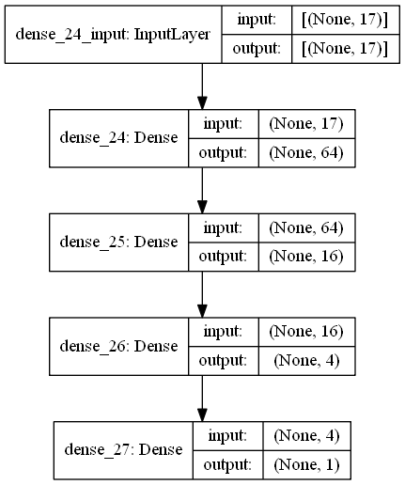

神經網路訓練 MSE 誤差

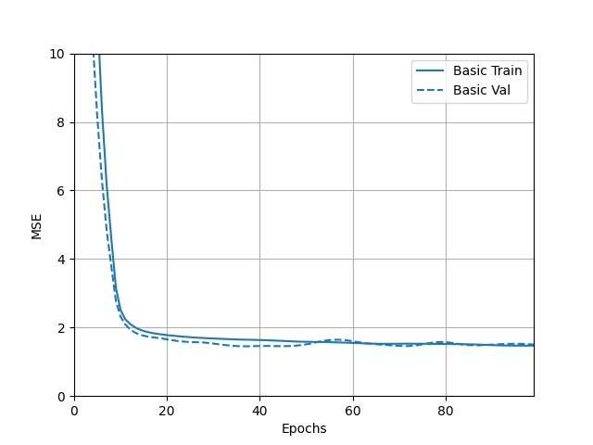

預測成績分布

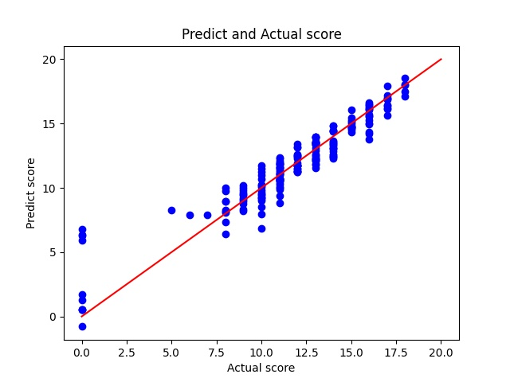

模型誤差如下

mean_squared_error = 1.62

mean_absolute_error = 0.836

median_absolute_error = 0.615

使用 r square 計算誤差

r square = 0.855

實際誤差分布百分比

error <= 0.5, 共 74 筆資料 約 37.95%

error <= 1.5, 共 174 筆資料 約 89.23%

error <= 2.5, 共 189 筆資料 約 96.92%

# 分析報告結束